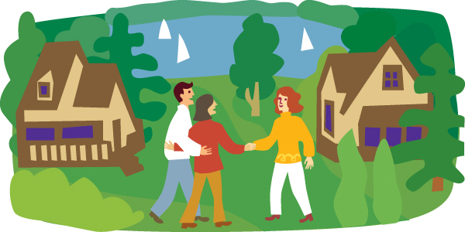

Neighbors

1. How well do you know your neighbors? (very well, a little, not at all)

2. Describe your neighbors (age, occupations, tall/short, old/young, friendly/not so friendly)

3. How often do you talk to your neighbors? What do you talk about?

4. Have you ever borrowed anything from your neighbors? If so, what?

