Trip Planning

A. Match each word with the correct meaning. Write the letter of the correct definition beside each word.

- intersection _____ | a. a popular place
- address_____ | b. street number and name
- landmark _____ | c. change to a different bus or train
- stop number _____ | d. get to a place
- depart _____ | e. student or senior fare
- arrive _____ | f. how long it takes
- duration _____ | g. where 2 streets cross
- transfer _____ | h. the number on the bus stop sign
- concession fare _____ | i. leave a place
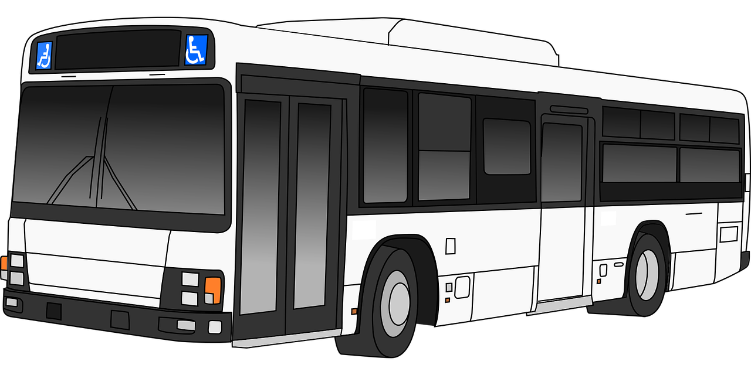

Trip Planning
B. Using Trip Planner – Step by Step Instructions
- Go to www.translink.ca and choose “trip planning”
or
- Do a google search for “bus in Burnaby” or “skytrain in Burnaby”. Then click www.transink.ca from the search results. Choose “trip planning”.
Step 1
Enter where you are departing from.
Enter where you are going to.
Enter your departure or arrival time.
Press “next step”.
Step 2
Select one of the results for where you are departing from.
Select one of the results for where you are going to.
Press “next step”
Step 3
View your trip options.
Click on “view detail” to see the details of your trip.

Practice One
Use “Trip Planning” on translink.ca to get directions from and to the following places.
Departing from: Metrotown
Going to: Science World, Vancouver
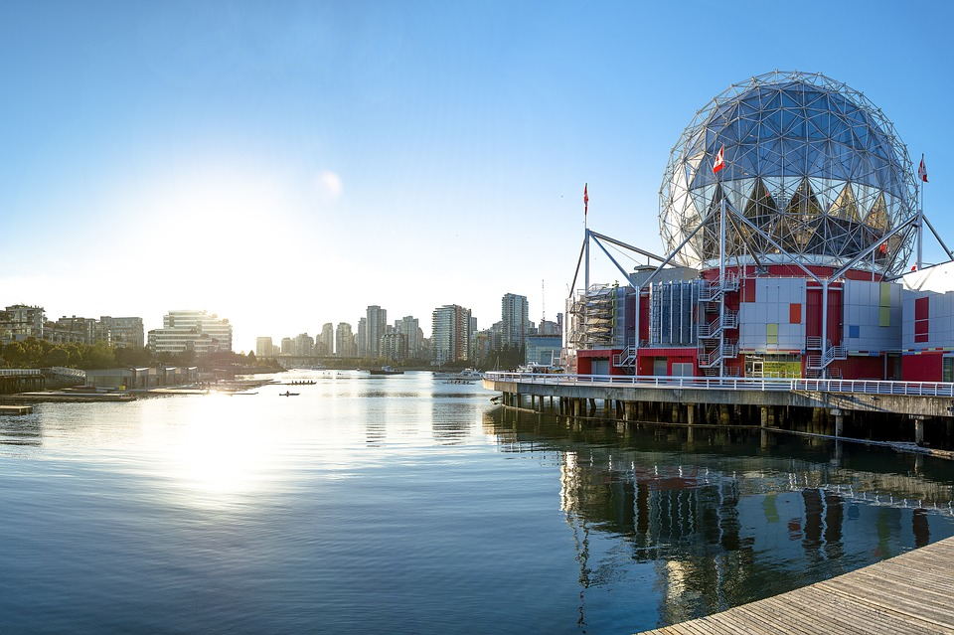
Questions:
- How long does the trip take on the Expo line?
________________________________________________________

- How much is the fare?
________________________________________________________

- How many transfers do you need to make?
________________________________________________________

Practice Two
Use “Trip Planning” on translink.ca to get directions from and to the following places.
Departing from: Metrotown
Going to: Queen Elizabeth Park, Vancouver
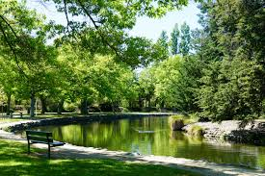

Questions:
- How many trip options are there?
________________________________________________________
- What bus can you take from 29thAvenue Station?
________________________________________________________
- How many transfers do you need to make?
________________________________________________________
- Which is the fastest trip option?
________________________________________________________
Practice Three
Use “Trip Planning” on translink.ca to get directions from and to the following places.
Departing From: Simon Fraser University, Burnaby
Going to: Lonsdale Quay, North Vancouver
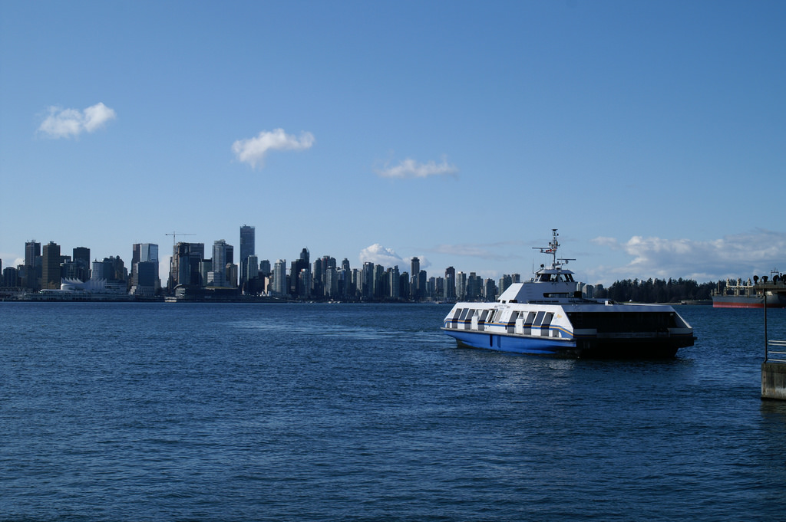
Questions:
- How many different types of transportation can you see in the trip options? What are they?
________________________________________________________

- What is the shortest trip time? Longest trip time?
________________________________________________________

- Which option would you take? Why?
________________________________________________________

