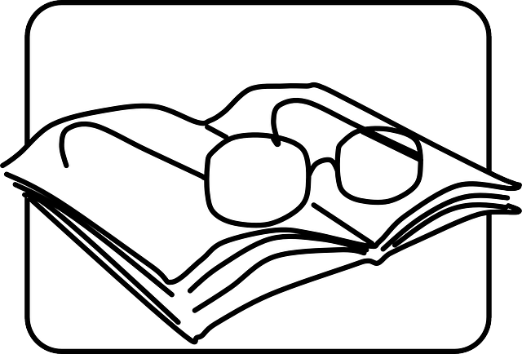
READING STRATEGIES

Good readers use several strategies to help them understand what they read. Below are some suggested strategies and resources for practice:

- Think about what you already know about the topic (background knowledge) of the text.
- Try to predict what the reading might be about. Look at the title, headings, pictures and captions to help you understand the text.
- Skim (look at the overall reading) to find the main idea
- Scan to find key details (look for key words and phrases)
- Look at the topic or first sentences of paragraphs to find information
- Look at the layout and organization to help you find information
- Look at bolded words and large fonts for important information
- Try to guess meanings of unknown words from the context and from information around the word
- Look for synonyms (words with the same meaning)
- Read the instructions carefully before reading the text
- Focus your reading – read the questions before you read the text in detail
- Remember you don’t have to understand every word to complete the task (you don’t need word-by-word comprehension)
- Think about what kind of reading it is. What is the reading’s purpose?
- Understand the level of formality, tone, mood and politeness – what words or cues helped you?
- Look for sequence markers (words) to help you with instructions and the organization of information.
- Check your answers.
- Rephrase to check your comprehension.

RESOURCES and PRACTICE

These resources will give you more helpful tips and practice with these strategies.

- Learn more about how to use context clues to guess the meaning of unknown words.
- Watch this helpful video: https://www.youtube.com/watch?time_continue=322&v=Wm5d7c0xGt0
- Read “Guessing Unknown Words”: https://www.eapfoundation.com/reading/skills/guess/

- Learn more about skimming
- Read: https://www.eapfoundation.com/reading/skills/skimming/

- Learn more about scanning
- Read: https://www.eapfoundation.com/reading/skills/scanning/
- Practice. Go to: https://www.cambridgeenglish.org/learning-english/activities-for-learners/b2r005-learning-about-archery
And: https://www.cambridgeenglish.org/learning-english/activities-for-learners/b1r002-shopping-in-a-department-store

4. Practice paying attention to discourse markers (transition words) to understand a text.
- Go to: https://www.cambridgeenglish.org/learning-english/activities-for-learners/b2w001-organising-writing

- Practice reading for detail
- Go to https://www.cambridgeenglish.org/learning-english/activities-for-learners/b1r001-arranging-to-meet
- Go to https://www.cambridgeenglish.org/learning-english/activities-for-learners/b1r005-websites-for-teens

- Practice reading for implied meaning
- Go to https://www.cambridgeenglish.org/learning-english/activities-for-learners/b2r002-being-an-adult

- Learn more and practice reading for main idea
- https://www.ccis.edu/offices/academicresources/writingcenter/studyskills/textbookreadingstrategies/findingthemainidea-test.aspx?utm_expid=.5zFwyQyUQ9qA-54BrqFgdg.1&utm_referrer=https%3A%2F%2Fwww.google.com%2F
- https://www.mdc.edu/Kendall/collegeprep/documents2/MAIN%20IDEASrevised815.pdf
- https://www.thoughtco.com/how-to-find-the-main-idea-3212047
- Main Idea Worksheet 3: https://0.tqn.com/z/g/testprep/library/Reading_Worksheets/Main_Idea_Worksheet_3.pdf
- Answers for Main Idea Worksheet 3: https://0.tqn.com/z/g/testprep/library/Reading_Worksheets/Main_Idea_Worksheet_3_Key.pdf

8. Learn more about understanding a text’s purpose
- https://www.gardencity.k12.ny.us/cms/lib/NY01913305/Centricity/Domain/721/Authors%20Purpose%20Notes%20and%20Strategies.pdf

