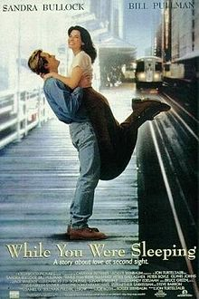
While You Were Sleeping

Movie Characters
Lucy | ~ train station employee
Peter Callaghan | ~ handsome stranger
Jack Callaghan | ~ Peter’s brother
Ox & Midge | ~ Peter’s parents
Elsie | ~ Peter’s grandmother
Mary | ~ Peter’s sister
Saul | ~ friend of the Callaghan family
Joe | ~ Lucy’s landlord
Joe Jr. | ~ Joe’s son
Jerry | ~ Lucy’s boss
Ashley | ~ Peter’s girlfriend

Story
Lucy lives alone in Chicago. She sells tokens at the train station. She’s secretly in love with a handsome stranger who takes the train every day. On Christmas Day, he is mugged at the station. Lucy saves his life, but is in a coma. There is a misunderstanding at the hospital, and the man’s family think Lucy is his fiancee.

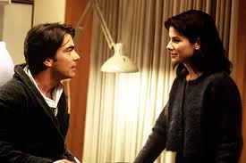

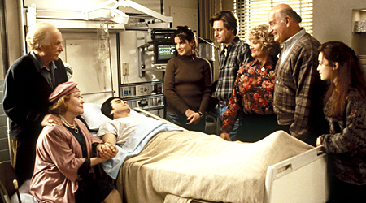
While You Were Sleeping
Comprehension Questions

Part 1
ANSWER TRUE (T) OR FALSE (F)
- __________ Lucy doesn’t have any family.
- __________ Lucy likes Joe Jr.
- __________ Lucy works on Christmas Day because he wants more money.
- __________ Peter’s family is happy that Lucy is Peter’s fiancée.
- __________ Peter is a doctor.
- __________ Saul knows that Lucy really isn’t Peter’s fiancée.
- __________ Lucy goes to the hospital at 2PM to see Peter.
- __________ Lucy brings a poinsettia to the Callaghan Christmas party.
- __________ Ashley leaves Peter a message on his answering machine.
She says that she will marry him.

- __________ Peter’s family buys and sells furniture.
- __________ Jack doesn’t believe that Lucy is Peter’s fiancée.
- __________ Jack gives Lucy & Peter a rocking chair as a wedding present.
- ________ Lucy likes Peter’s family.
- ________ The cat in Peter’s apartment is called Fluffy.
- ________ Lucy tells Jack that she carries her passport with her.
- ________ Lucy tears her pants when she and Jack fall on the ice.
Part 2
ANSWER TRUE (T) OR FALSE (F)
- __________ Everybody thinks Lucy is pregnant.
- __________ Peter wakes up on New Year’s Day.
- __________ The doctor says Peter has amnesia.
- __________ Lucy is happy that she is going to marry Peter.
- __________ Jack gives Lucy a snow globe of Florence.
- __________ Peter and Lucy kiss under the mistletoe.
- __________ The Callaghan family is angry when Jack and Lucy get engaged.

- __________ Lucy and Jack go to Italy for their honeymoon.
